Assignment - 4

1. Prepare a file to import.
a. Launch Data Import Wizard
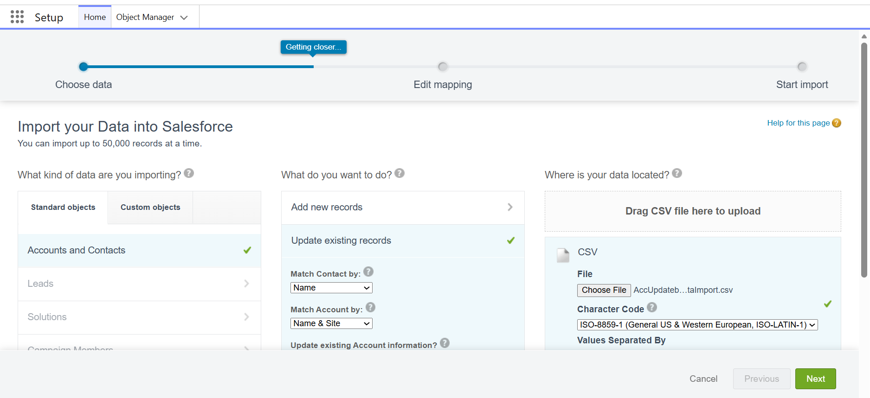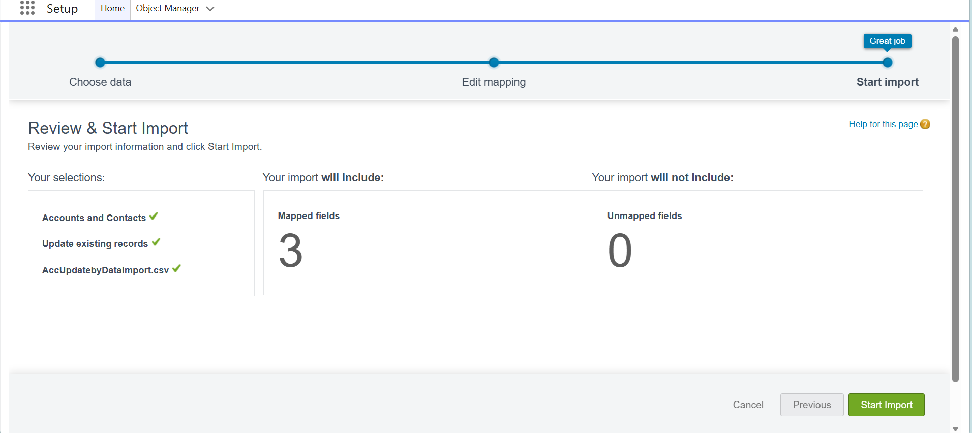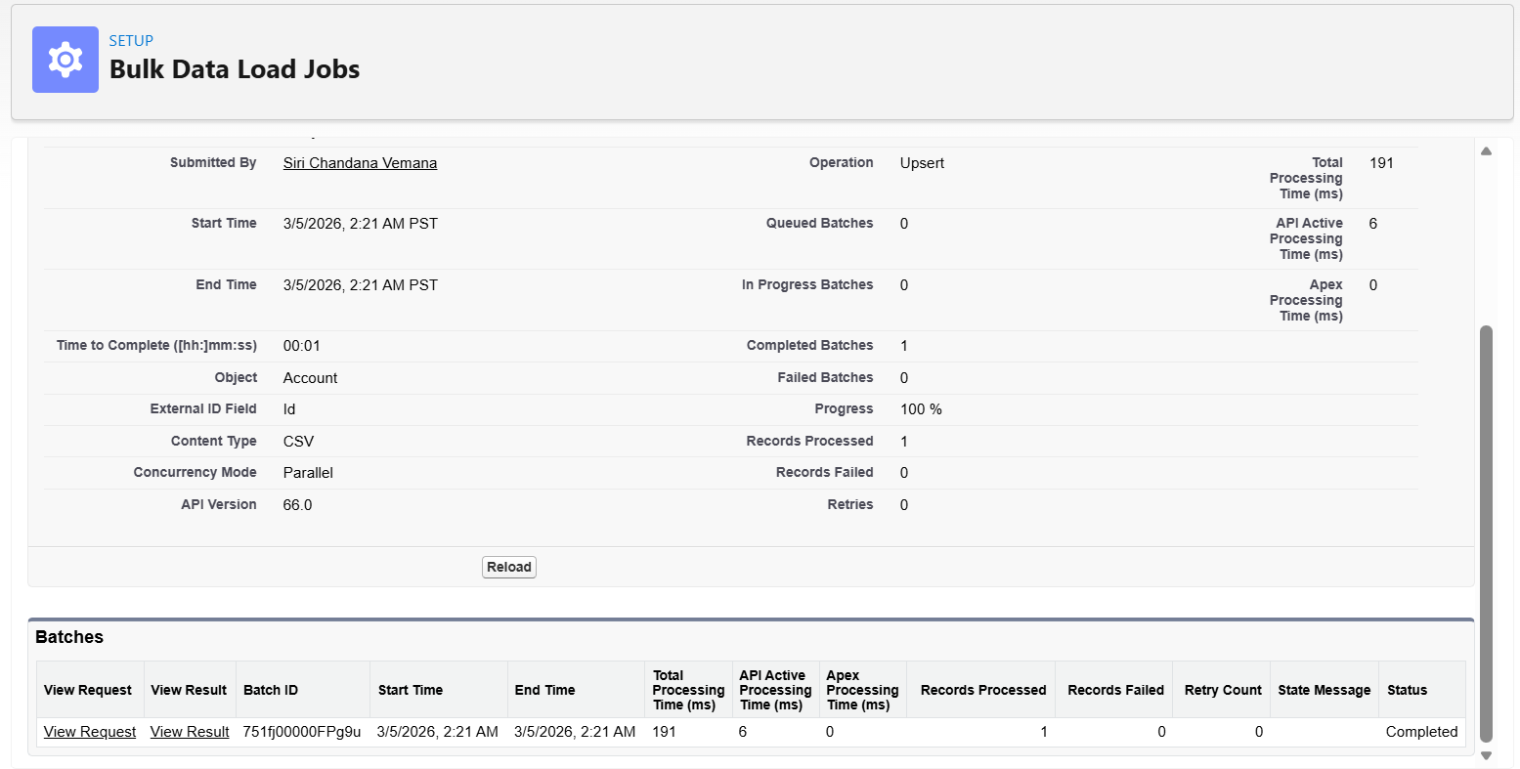
2. Use Data Loader to export data.
a. Use Data Loader to update the records you have exported in the previous step, filling in site information for the companies on the list to allow the sales team to identify those firms by their regions.
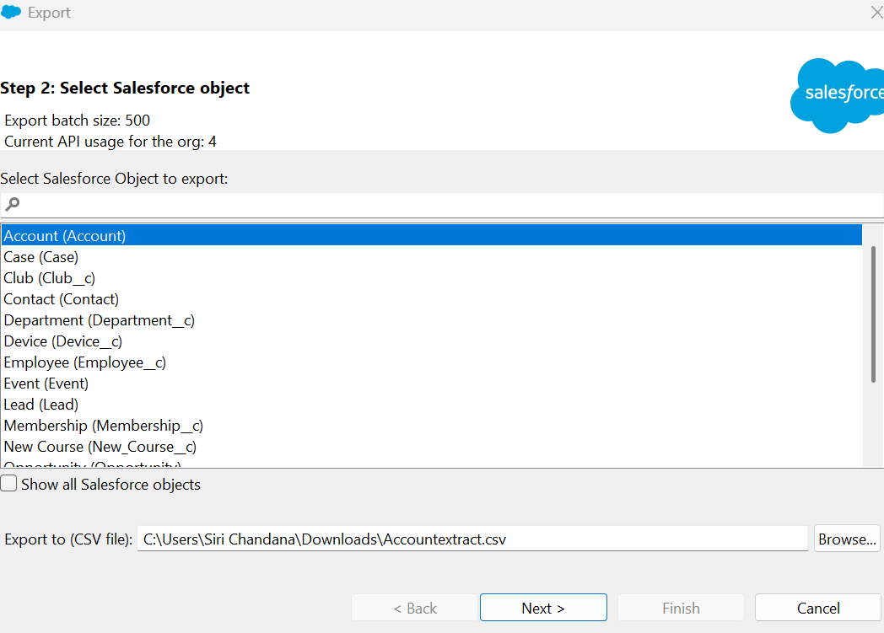
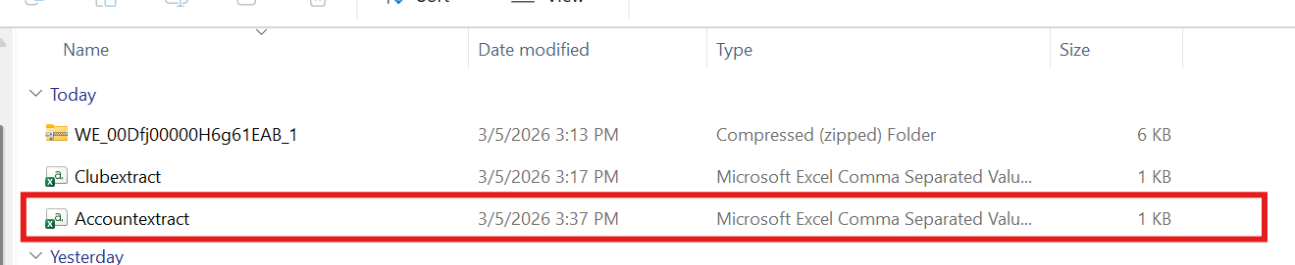
Updating as below,
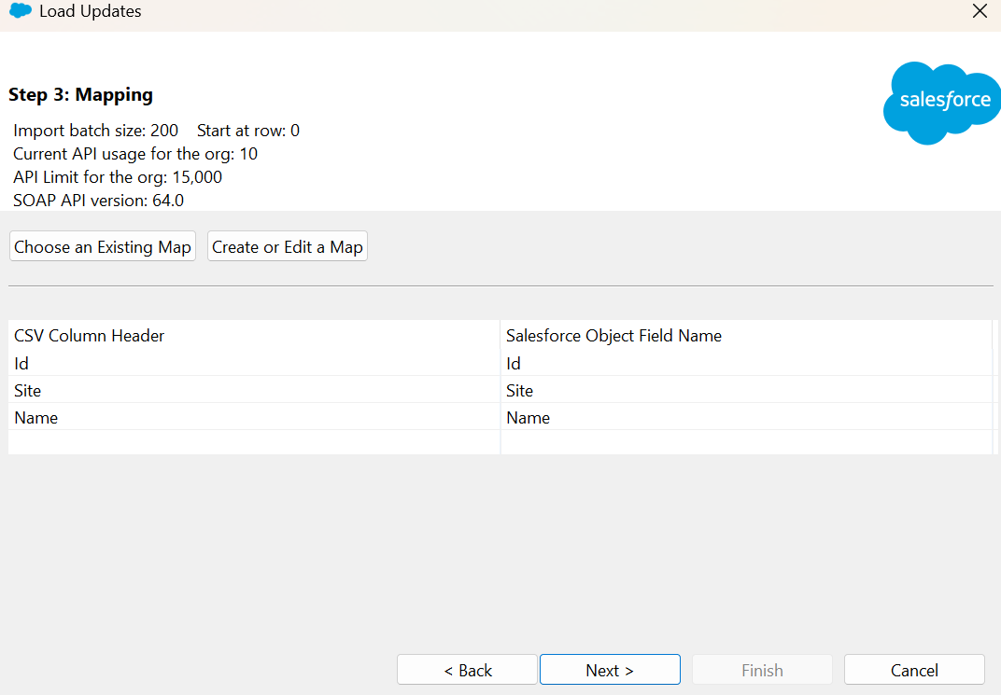
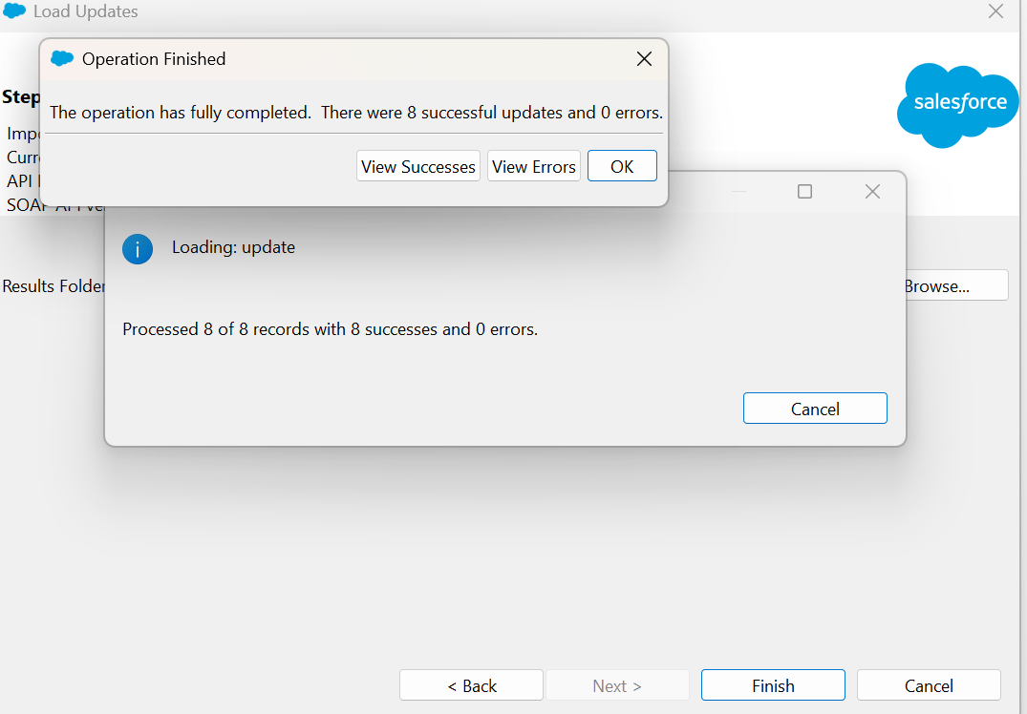
Updated
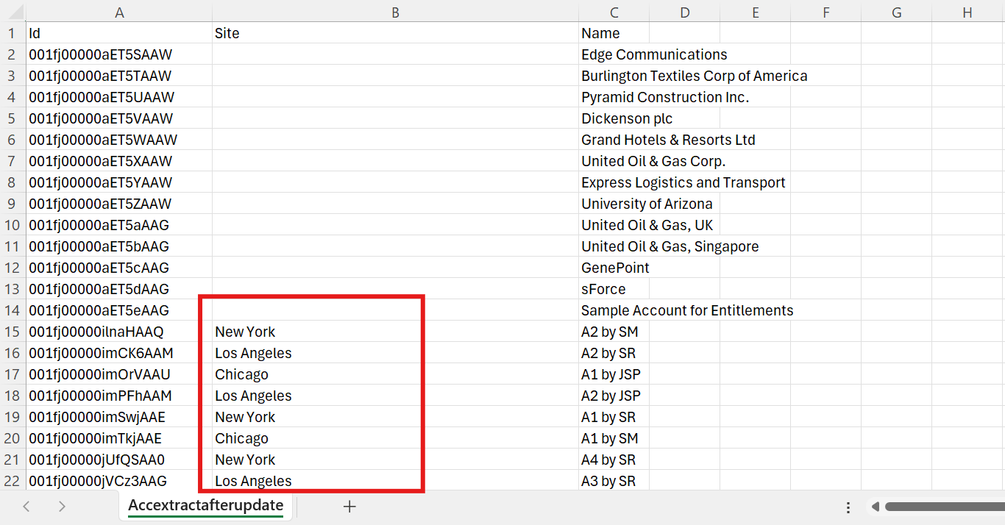
3. Use Data Export Services of Salesforce to export your organizations’ data.
